Project Development Phase
Model Performance Test

Date | 10 February 2025
Team ID | PNT2022TMIDxxxxxx
Project Name | Project - xxx
Maximum Marks

Model Performance Testing:
Project team shall fill the following information in model performance testing template.
S.No. | Parameter | Values | Screenshot
 | Model Summary | Artificial Neural Network (Multi-Layer Perceptron)  Architecture: Input(4) -> Dense(16, ReLU) -> Dense(8, ReLU) -> Output(3, Softmax)  Optimizer: Adam (learning rate 0.05) | Dataset: sklearn Iris | Epochs: 20 | 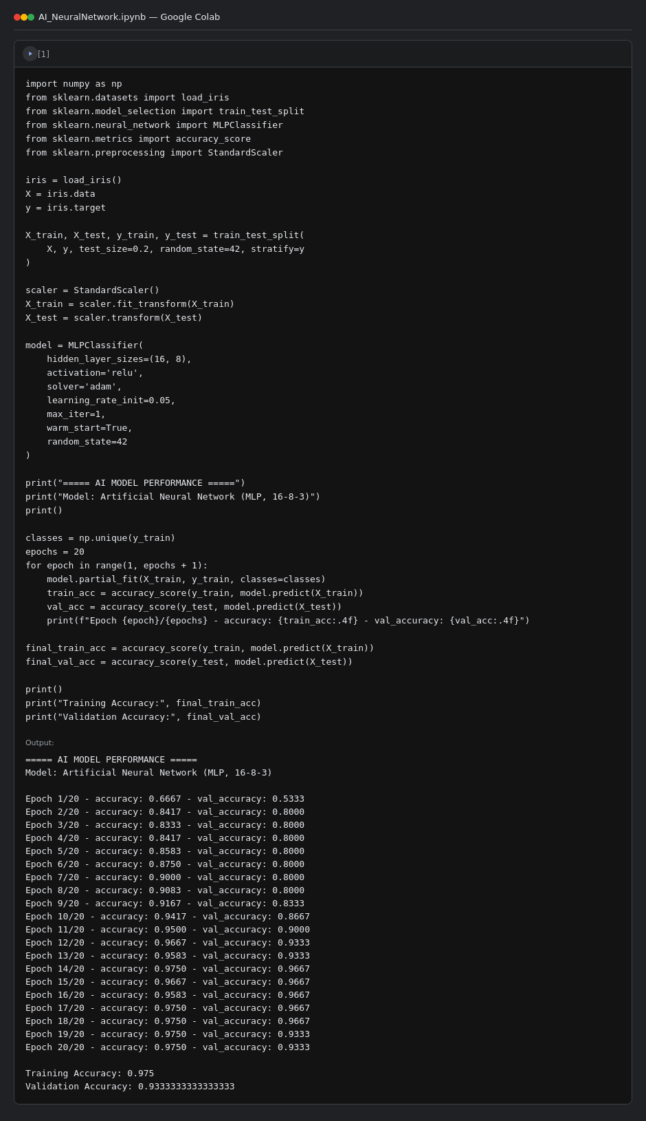
 | Accuracy | Training Accuracy - 0.975 (97.5%)  Validation Accuracy - 0.9333 (93.33%)
3. | Fine Tunning Result( if Done) | Not performed for this demo model (no fine-tuning pass run beyond the 20 training epochs above)

